**Lab Exercise 5:**

1. For understanding more about arrays, try creating an array that has 5 elements.
2. Replace the value of the element at position 1 and 4.

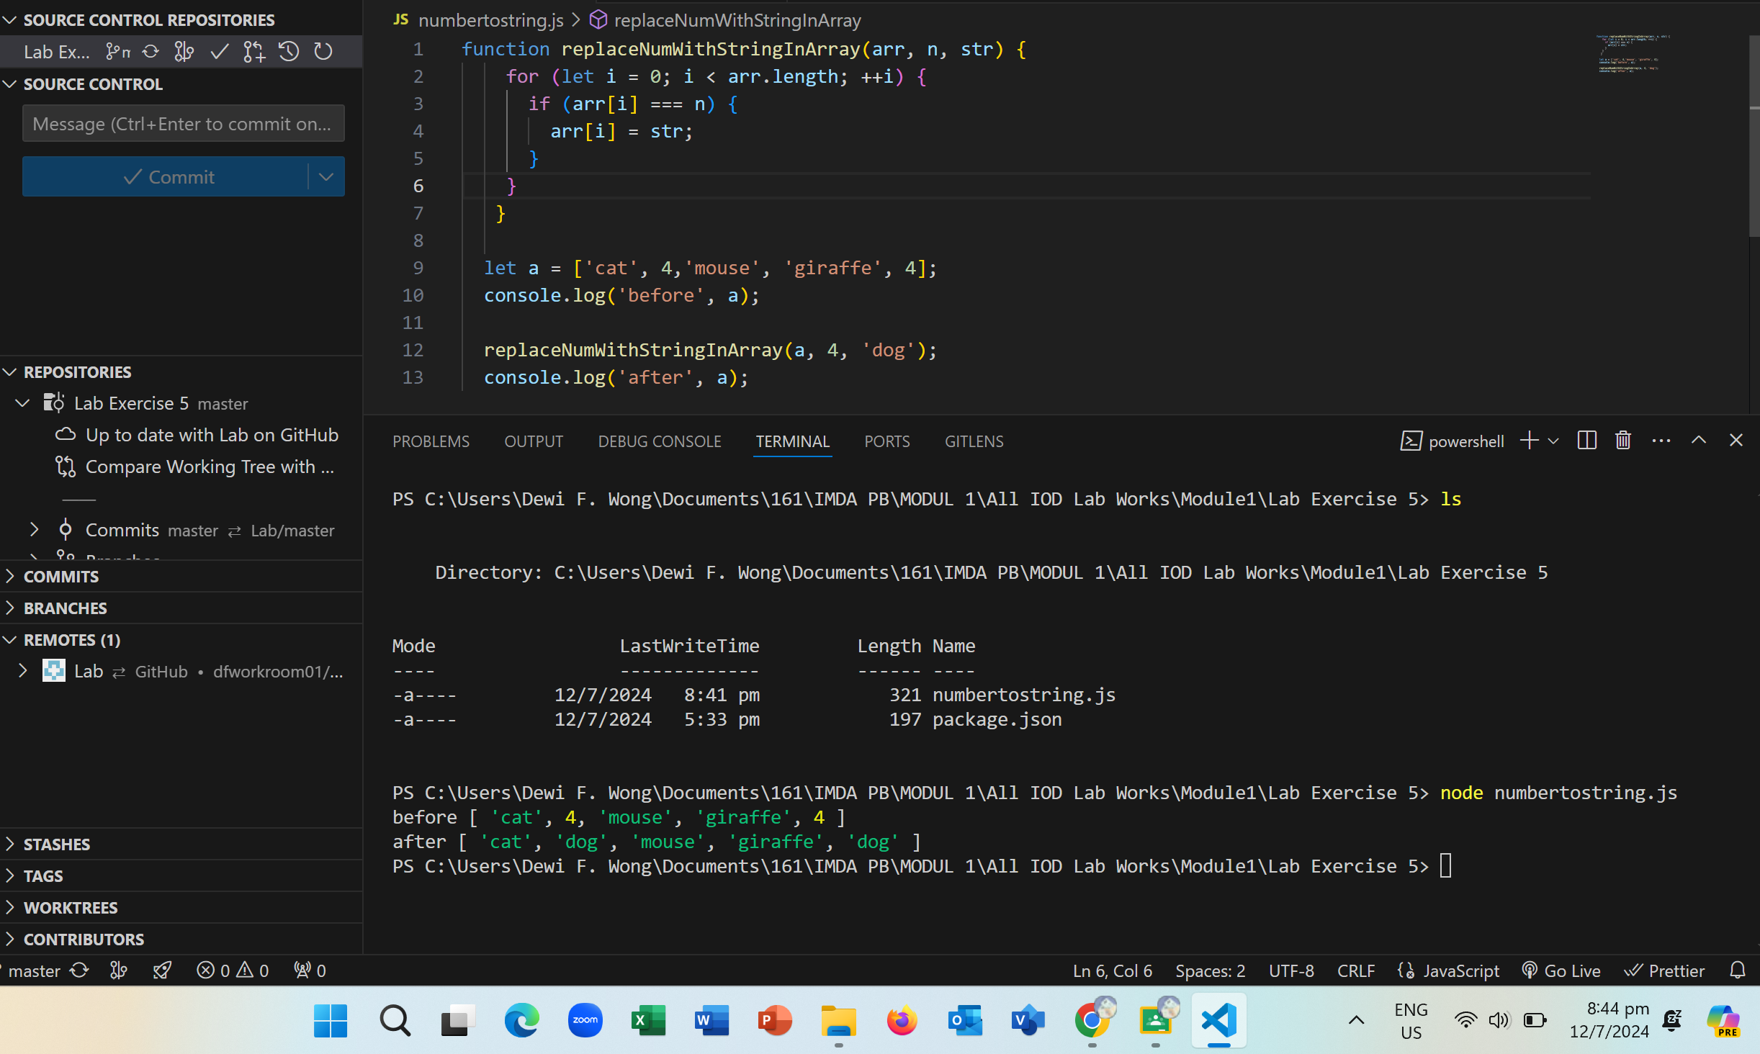

1. Add a new element to the beginning of the array

1. Remove the element at the end of the array
2. Print the array to the console.

Extension:

Attach the VS Code debugger to your script and add a breakpoint on the first line. Step through your code line by line to watch how it executes.

Added comments for codes and the results:

